**

**‘O’ LEVEL MARKING GUIDE**

**GEOGRAPHY**

Paper 1

***PART I OBJECTIVES***

|  |  |  |  |  |  |
| --- | --- | --- | --- | --- | --- |
| *1* | *A* | *11* | *C* | *21* | *C* |
| *2* | *A* | *12* | *B* | *22* | *A* |
| *3* | *C* | *13* | *C* | *23* | *D* |
| *4* | *C* | *14* | *B* | *24* | *C* |
| *5* | *D* | *15* | *C* | *25* | *B* |
| *6* | *D* | *16* | *B* | *26* | *B* |
| *7* | *C* | *17* | *A* | *27* | *A* |
| *8* | *B* | *18* | *D* | *28* | *C* |
| *9* | *D* | *19* | *B* | *29* | *A* |
| *10* | *C* | *20* | *C* | *30* | *D* |

*a) (i) The grid reference of Kuangaro Seconday Trigonometrical station is*

*38 68 *

*(ii) the physical feature at grid reference 606700 is a papyrus swamp / permanent.*

*b) (i) Masaka is located in the southern hemisphere because;*

* *It is a long latitude 0o201 south of equator*
* *Latitudes 0o15, 0o201 increase southwards from the equator.*
* *Latitudes 2o20o, 0o151 decrease northwards.*

*Hemisphere (H)*

*Reason (R)*

*(ii) Calculate the vertical interval of the area on the map. (02marks)*

*Vertical interval of Masaka is;*

*4300 – 4200m = 100ft*

*4200 – 4100m = 100ft*

*NB: Consider any two nearby contour heights from the map extract*

*(c) (i) Giving evidence from the map, identify the economic activities taking*

*place in the area shown on the map. (04 marks)*

* *Forestry at Kinvurikide, Kumbu, Kamenyamigo etc because of the presence of forests.*
* *Wild life conservation at Kingunikide, Kumbu, Kamenyamigo because of the presence of forests*
* *Agriculture due to the presence of agricultural department at Kamenyamigo*
* *Crop cultivation / coffee growing / cotton growing due to the presence of plantations at Butego, Kingo, Lwamachu etc coffee factory at Bukoto etc ginnery at Gayaza.*
* *Crop / coffee / cotton processing industrialization due to the presence of coffee factories at Nkoni, Kynja, Masaka town etc*
* *Trade at Masaka town due to dense settlement, settlement alont Masaks – Mabirizi and Mbarara all weather read bound surface at Nkoni, Bukoto, Coffee factory at Kyanja etc*
* *Road transport due to the Mbirizi and Mbarara – Masaka all weather road bound surface, Villa Maria, - Nyendo and Masaka road, etc*

*Any 4 with evidence x 01*

*(ii) Describe the relationship between drainage and transport in the area shown on the map. 03marks)*

* *Papyrus swamps like Nabajuzi etc are crosses by all weather roads bound surface Mbirizi and Mbarara to Masaka road*
* *Papyrus swamps like Kajansembe is crossed by dry weather roads*
* *Papyrus swamps at Kimanya is crossed by all weather road loose surface*
* *Papyrus swamp e.g. Kisansala is crossed by motorable /main trucks*
* *Papyrus swamp like Nabajuzi is crossed by foot paths*
* *Seasonal swamps Lusamatu, Mukunge etc are crossed by dry weather roads*
* *Well drained areas like Bukoto, Butego have dry weather roads*
* *Seasons swamps at Kabale is crossed by Masaka Mabirizi and Mbarara all weather road bound surface*

*NB: The correct geographical relationship should*

* *Clearly be brought out*
* *Areas of the relation ship should be brought out*

*d) Draw a sketch map of the area shown on the map and on it, mark and name:*

***A CROSS SECTION OF MASAKA BETWEEN EASTIGN 47 AND 53 ALONG NORTHING 70 SHOWING PHYSICAL AND HUMAN FEATURES / ROAD, SETTLEMTNS BROAD VALLEY, SEASONAL SWAMP AND HILL***

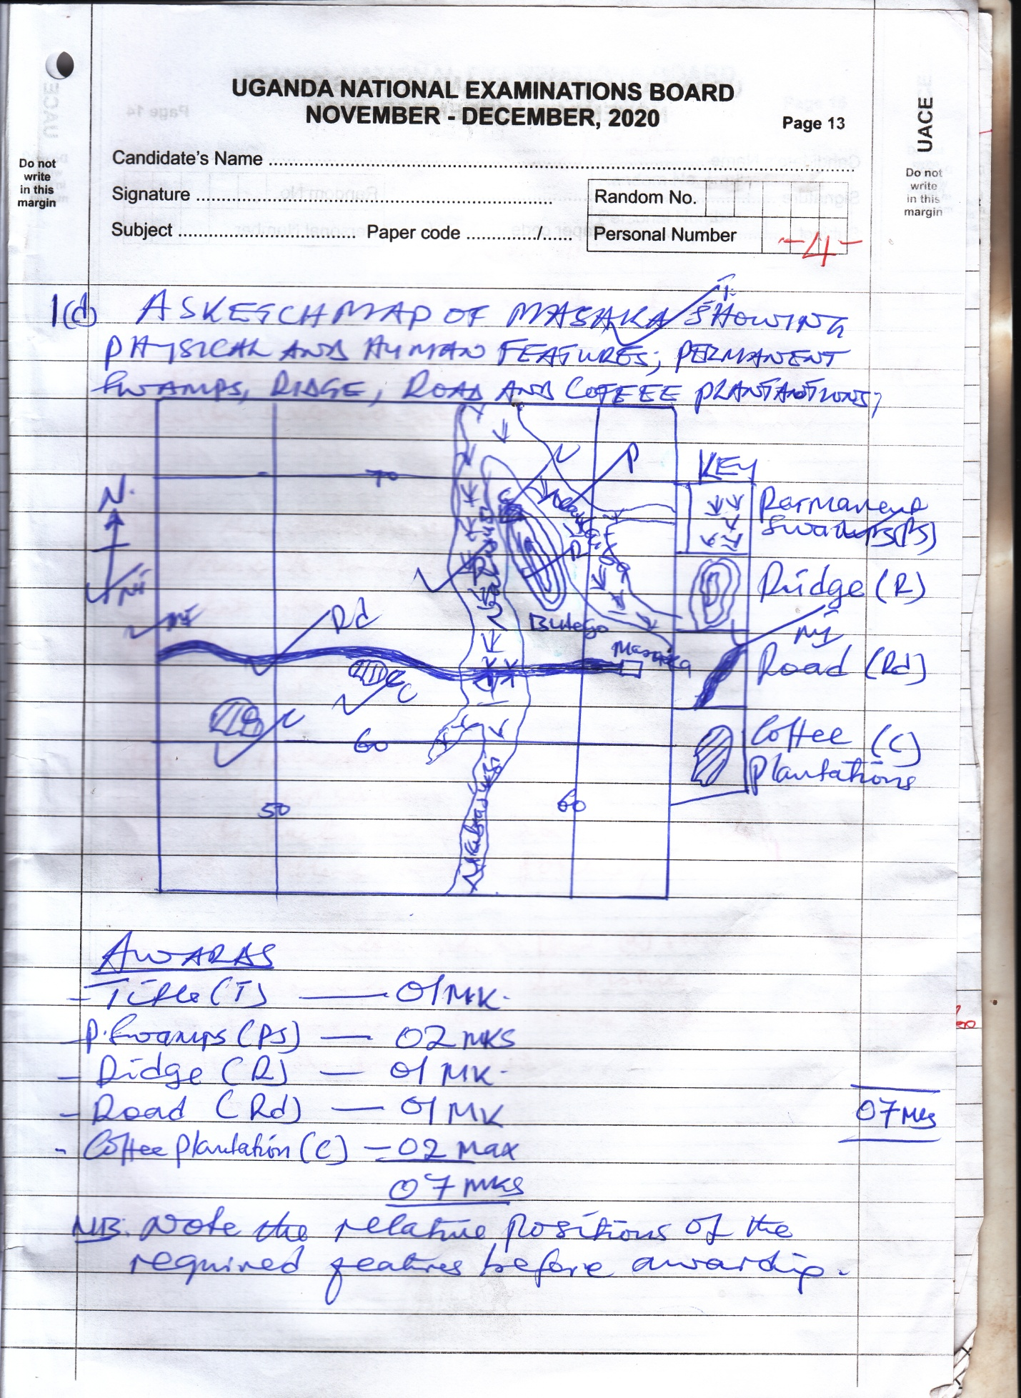

*NB: Note the relative positions of the required features before awarding.*

***2. PHOTOGRAPH INTERPRETATION (COMPULSORY QUESTION.***

***(15 MARKS)***

*Attempt* ***ALL*** *parts of this question.*

*Study the photograph provided below and answer the questions that follow:*

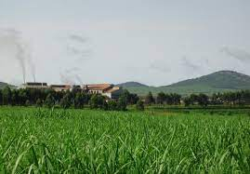

1. *Name any* ***two;***
2. *Relief features,*

* *Hill / ridge in the right middle ground*
* *Upland in the right middle ground*
* *Saddle / col in the right middle ground*
* *Gentle slope in the central and left middle ground*
* *Low land / flat land in the foreground etc*

*Any 2 x 1 = 2 marks*

1. *Land use activities, in the photograph.*

* *Crop cultivation / plantation farming in the fore ground*
* *Settlement or industrialization in the central and left middle ground*
* *Road transport in the central and right middle ground*
* *Foresting in the right middle ground*

*Any 2 x 1 = 2 marks*

*NB: all the relief and land uses must be located to earn marks.*

*Never award features named but note located i.e. relief and land uses*

1. *Describe the* ***physical*** *conditions that have favoured the major land use shown in the fore ground of the photograph above.*

*The landuse activity is plantation farming / sugar cane growing or crop growing.*

***Conditions***

* *Presence of extensive land in the foreground for the establishment of the farm / plantation farming or crop growing*
* *Presence of fertile soils in the fore ground that enable crop growing as seen by the healthy crops*
* *Presence of a relatively flat landscape or lowland in the fore ground for easy cultivation*
* *Presence of well drained soils in the foreground that have enabled crop growing*
* *Presence of reliable water supply or heavy rainfall seen by the luxuriant or healthy crops in the foreground.*
* *Presence of hot temperatures in the foreground due to lowlands or healthy crops or clear skyline*
* *Presence of sunny conditions which enable photosynthesis seen by clear skies in the photograph or healthy crops*
* *Identification of conducive(id) – 01*
* *Well described factors - any 4 x 1*

1. *Outline the importance of the land use in (b) above to the people of the area where the photograph was taken.*

* *It is a source of employment to the people especially those working on the farm; income;*
* *The landuse or crop farming has provided people with skills leading to increased production*
* *It stimulates or encourages the growth of industries or processing leading to economic development*
* *The landuse encourages or stimulates the development of social surfaces i.e. schools, health facilities etc*
* *Encourages the growth of trading centres or towns which promotes trade activities*
* *Promote the development of transport infrastructure leading to easy movement.*
* *Is it a source of revenue to the government leading to development of other sectors or infrastructure*
* *The land use is used for study and research purposes*
* *The values or importances must be brought out in complete sentences.*

*Any 4 x 1 = 4marks*

1. *Giving reasons for your answer, name any one area in East Africa where the photograph could have been taken.*

*Possible areas; Lugazi, Kakira, Mayuge, Kinyara, Amuru, Kaliro, Mumias, Bukoba, Kilombera, etc*

***Reasons:***

*Large sugar cane plantations,*

*Sugar cane growing*

*Factory within in the sugar cane plantation / estate*

*Area (A) - 01*

*Reason (R) - 01 mark*

***3. COMPULSORY QUESTION: FIELDWORK (15 MARKS)***

*Attempt* ***all*** *parts of this question*

*For any* ***one*** *field work study you have conducted either as a group or an individual:*

*a) (i) The topic of study must be a geographical statement, with “What” was studied and “where” the study took place “what” and “where” are tied together to score.*

*(ii) The objectives of the field work study must be related to the topic of study*

*The should be stated with functional verbs; e.g. To find out……*

*To establish……..*

*To discover………….*

*Never accept abstract / ambiguous expression like to know…..*

*To understand….*

*To measure….*

*Any 2 x 1 = 2 marks*

*b) Describe any* ***two*** *activities you carried out when conducting the field work study. (04 marks)*

*the activities during the study must be identified. Application seen and the finding / outcome of the activity given.*

*The following activities may be identified.*

* *measuring*
* *observation*
* *recording*
* *interviewing*

*NB: Identification of activity and application*

*Finding / outcome of the activity*

*Any two*

*c) Explain the geographical importance of your fieldwork study.*

*This requires the candidates to brign out the relationship identified during the study with reasons.*

*The identified relationship may be physical to physical, physical to human and human to human aspects.*

*Any 3 x 1*

*d) Draw a sketch map of the area of your study, on it mark and name;*

* *marginal information (MI) title, frame, key, award for the title only*
* *the physical featurs to be marked and named; vegetation types; forest, thicket etc*
* *relief features; hill, lowland, valley etc*
* *drainage features; lakes, swamps, river*
* *soil types, clay etc*
* *land use types showed include;*
* *transport routes*
* *farms*
* *settlement*
* *market*
* *factories*
* *foresting quarry*

***SECTION B: EAST AFRICA (20 MARKS)***

*Answer only* ***one*** *question from this section*

*4. a) Differentiate between a* ***Graben*** *and an* ***Escarpment****. (04 marks)*

* *A graben is a depression / hollow at the floor of the rift valley*
* *It is usually narrow in nature, have steep sides*
* *Graben is formed by secondary faulting*
* *It is always bounded by two parallel fanets on the floor of the valley*
* *Examples of grabens include the Albert Graben, Tanganyika graben, Turkana graben etc*

*Illustration / diagram*

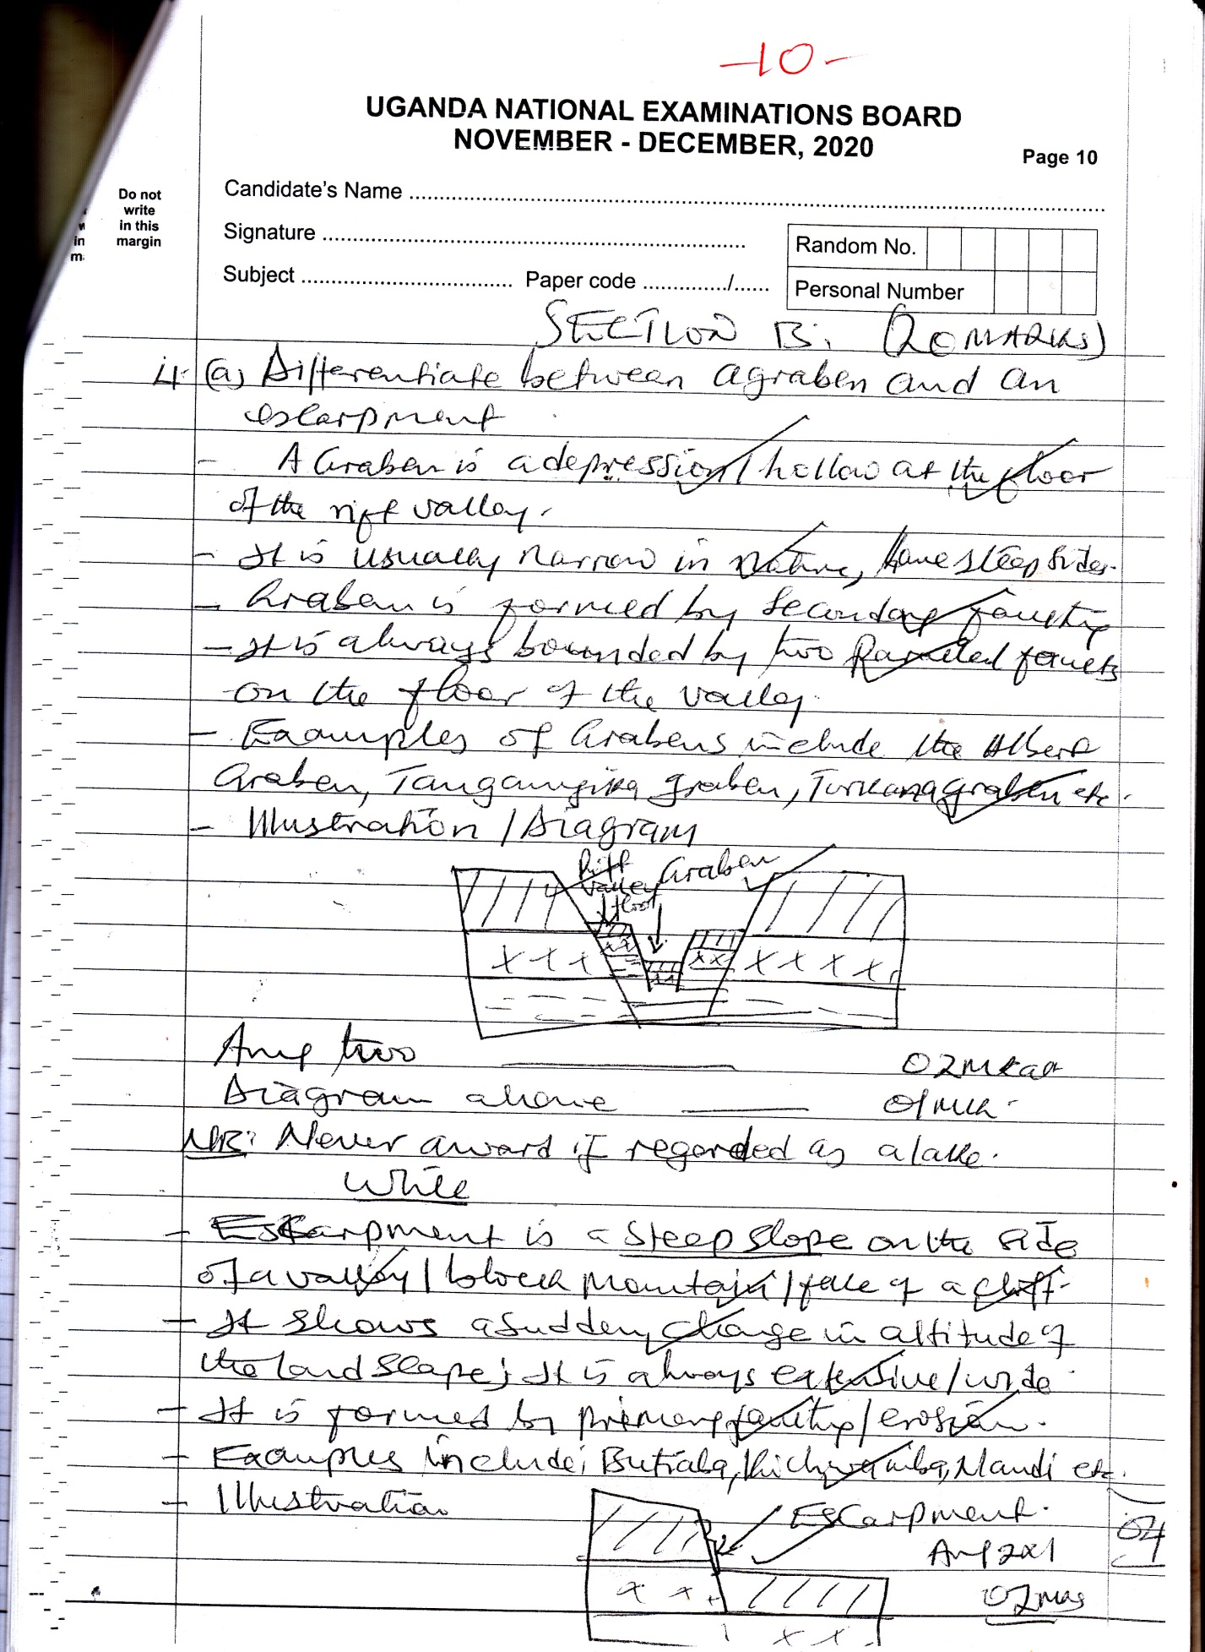

*Any two*

*Diagram above = 1 mark*

*NB: Never award if regarder as a lake*

*While*

* *Escarpment is a steep slope on the side of a valley / block mountain / tale of a cliff.*
* *It shows a suddenly change in altitude of the landscape; it is always extensive / wide*
* *It is formed by primary faulting / erosion*
* *Examples include; Butiabe, Kichwamba, Nandi etc*

*Illustration*

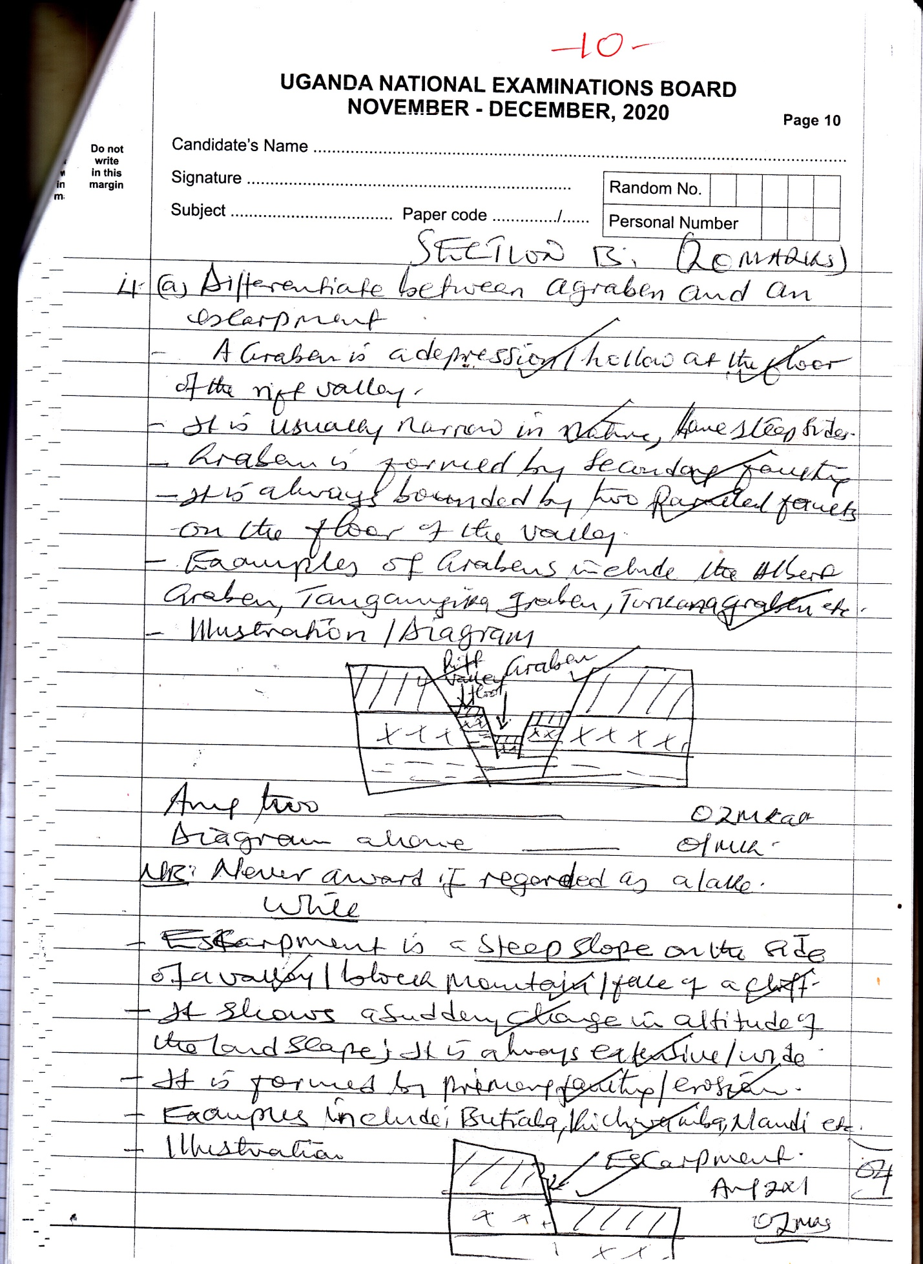

*b) (i) Name any two grabens in East Africa;*

*albert graben, Tanganyika graben, Manyara graben, Adward graben, Turkana Graben etc Any 2 x 1*

*NB: Never award for lakes.*

*(ii) Grabens are formed by secondary faulting on the floor of the rift valley.*

* *This mainly caused by diverging / tensional forces or converging / compressional forces in the crust at the floor of the rift valley*
* *Through tension, the forces pull the crust at the floor of the rift valley apart;*
* *This causes stress and strain on the crust leading to the development of secondary or minor faults / fractures on the rift valley floor*
* *The continued tensional pull widens the faults or fractures, dividing the crust at the floor of the valley into faulted blocks*
* *The central block collapses or sinks under its weight, leaving behind a depreseion or hollow on the floor of the valley called a graben.*

*Illustration*

*c) Explain the importance of grabens to the people of East Africa.(06 marks)*

* *Some graben areas contain minerals which promotes mining e.g. Albert graben for crude oil*
* *Grabens for a beautiful scenery which attracts toursists hence bringing foreign exchange*
* *Most graben areas have grassland vegetation which allows livestock reading*
* *Some grabens contain lakes which promote fishing actvitiies e.g. Albert, Tanganyika grabens*
* *Graben areas are also used for wild life conservation due to little rainfall and grass land vegetation*
* *Grabens are used for study and research in relation to tectonic movements*
* *The landscape around grabens also wallows fimling industry because of the beautiful scenery*
* *Some parts around the grabens have fertile soils which have attracted crop cultivation*

*Etc*

*NB: the values for grabens are brought as values for lakes do not award*

*d) Outline the problems faced by people living in areas with grabens in East*

*Africa. (04 marks)*

* *The areas around graben experience occasional flooding causing loss of life and property.*
* *Some parts of grabens are steep which causes soil erosion destroying formation*
* *Graben areas have hot temperatures which limits settlements.*
* *They experience little rainfalls which affects agricultural activities by the people*
* *The people experience attacks from dangerous wild animals since they are conservation areas.*
* *People in graben areas also experience attacks from disease vectors which transmit diseases.*
* *These areas are prove to earth quakes which destroys life and property*

*Any 4 x 1*

*NB: The outlined problems must be brought out in a complete and meaningful way with, cause or effect attached to score.*

*5. Study figure* ***1****: Sketch map of East Africa provided below and answer the questions that follow.*

*(a) Name the:*

*- 1 is George*

*- 2 is Rukwa*

*(ii) D is Sibiloi*

*E is Murchison falls*

*(iii) HEP stations A is Nalubaale / Kiira / Bujagali*

*B is seven folks / Kindaruma*

*C is Kidalu*

*(b) Describe the factors that led to the location of any* ***one*** *hydro-electricity power station named in (a) (iii) above. (04 marks)*

* *Nalubaale / Kiira / Bujagaali, Kidatu / seven folks any one may be identified;*
* *Presence of fast flowing water along the river for running the turbines*
* *Existence of hard basement rock along the river at this point to support the weight of the dam*
* *Presence of a narrow gorge / valley at the point for easy construction of the dam*
* *Presence of a large volume of constant flowing water fro the generation of HEP*
* *Presence of large land at that point for the construction of power station / houses*
* *Presence of a relatively silt free water which enable operation of turbines*

*Any 4 x 1 well described*

*(c) Explain the problems facing the power and energy sector in East Africa. (05 marks)*

* *Weather changes which affect the generation of some sources like HEP*
* *Exhaustion / depletion of some resources especially wood fuel causing shortages*
* *Breakdown of power and energy infrastructure of poles leading to difficulty in transmission*
* *Corruption in the energy and power sector which limits distribution and losses*
* *Shortage of skilled labour force in the sector which affects generation and distribution*
* *Vandalization / destruction of the energy infrastructure like cables which limits transmission*
* *Shortage of capital which has limited the construction of power plants to increase supply*
* *Break down of power and energy infrastructure which affects its supply.*

*Any five well explained 5 x 1 = 5 marks*

*Illegal connections causing losses to the energy and power sector*

*(d) Outline the steps being taken to promote the power and energy sector in East Africa. (04 marks)*

* *More dams are being constructed to increase the supply of power and energy*
* *New and alternative sources of energy are being used to reduce dependence on fossil fuels and hydro – electricity.*
* *Durable energy infrastructure is being introduced / used like concreate poles to reduce the break down of infrastructure for effective supply*
* *Training of personnel is being carried out so as to improve and increase generation and supply.*
* *Tough laws are being enacted to reduce power theft and destruction of its infrastructure*
* *The power and energy sector is being liberalized so as to improve on the supply and supervision*

*Any 4 x 1*

*NB: The steps must be presented in a present continous tense*

*6. Study table* ***1****; below showing selected mineral production in Uganda (2018-2019) and answer the questions that follow:*

*Table 1: Annual mineral production in Uganda in tonnes between 2018- 2019*

|  |  |  |
| --- | --- | --- |
| ***Mineral*** | ***2018*** | ***2019*** |
| *Limestone* | *170, 644* | *292, 770* |
| *Silica sand* | *237, 500* | *297, 715* |
| *Iron ore* | *45, 000* | *39, 050* |
| *Vermiculite* | *967, 400* | *1, 202,500* |

***Source: ministry of energy and mineral Development, status of mineral development (2020)***

1. *Draw a bar graph to show mineral production in Uganda in 2018.*

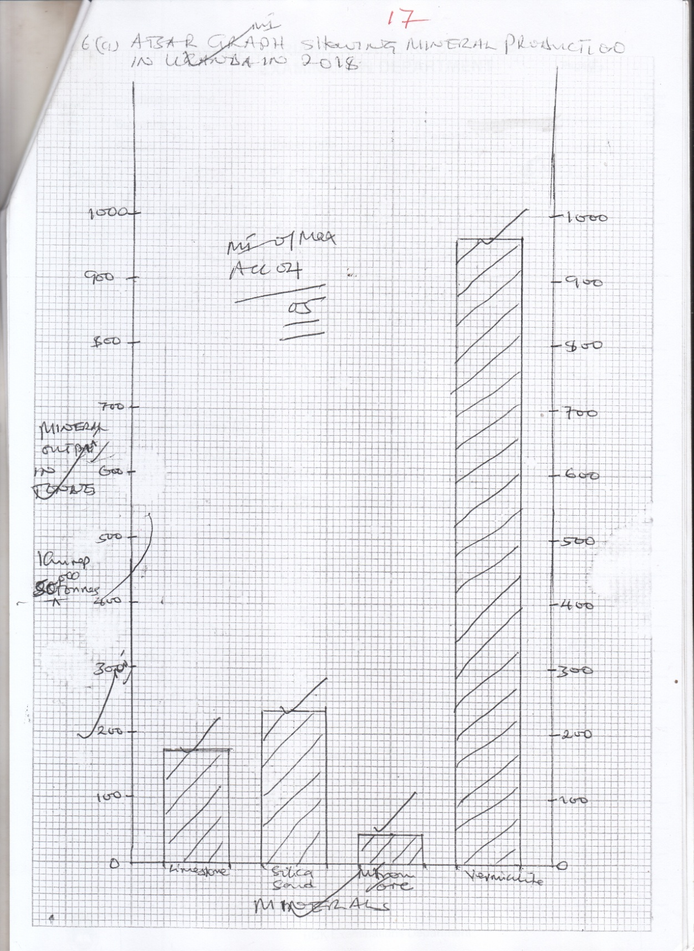 ***BAR GRAPH SHOWING MINERAL PRODUCTION IN UGANDA IN 2018.***

1. *(i) Calculate the percentage change in the production of Limestone and*

*Iron Ore in Uganda between 2018 and 2019.*

$$=\frac{New value - old value }{old value} x 100$$

$$= \frac{292,770 - 170,647}{170,644} x 100$$

$$= 716\% ≈72\%$$

*Any one between 2018 and 2019*

$$\frac{new value-old value }{old value } x 100$$

$$\frac{39,050 - 45,000}{45,000} x 100$$

$$= 13.2\% ≅ -13\%$$

*(ii) Describe the factors which have led to the trend of production of Limestone, Silica sand and Vermiculite in Uganda between 2018 and 2019. (04mark)*

* *Increased demand for limestone, silica sand and vermiculture has led to increased output / production.*
* *Widening market leading to increased in output*
* *More / increased capital investment in their production has led to increase in the production*
* *Use of improved / better method of mining leading to increased output production*
* *More research / discovery of more deposits leading to more exploitation or output*
* *Increased government support to the mining sector has led to increased output*
* *Improved political stability / security hence attractinv more investment to the mining sector*
* *Improved or developed road transport to their areas of extraction leading to increased production or output.*

*NB: Trend must be identified*

* *Factors must be related to the trend*

*Any 4 well described x 1*

*c) Explain the contribution of the mining industry to the economic development of Uganda.*

* *Source of foreign exchange to develop other sectors*
* *Source of employment hence income or better S.O.L*
* *Encourage diversification of economy wide tax base.*
* *Source of revenue from taxes to provide social services*
* *Promote industrial growth hence economic development*
* *Steers development of infrastructure or roads*
* *Growth of towns hence better social services.*

*Any 4 well explained*

*d) Outline the challenges facing the mining industry in Uganda. (03marks)*

* *Limited capital hence use of rudimentary methods*
* *Limited skilled labour hence use of expatriates*
* *Insecurity in some areas scares activities*
* *Remoteness of some mineral rich areas*
* *High taxes which discourage mining*
* *Land conflicts in mining areas hinder mining*
* *Corruption which hinders mining operations*

*Any 3 x 1*

*7. a) Draw a sketch map of East Africa on it mark and name:*

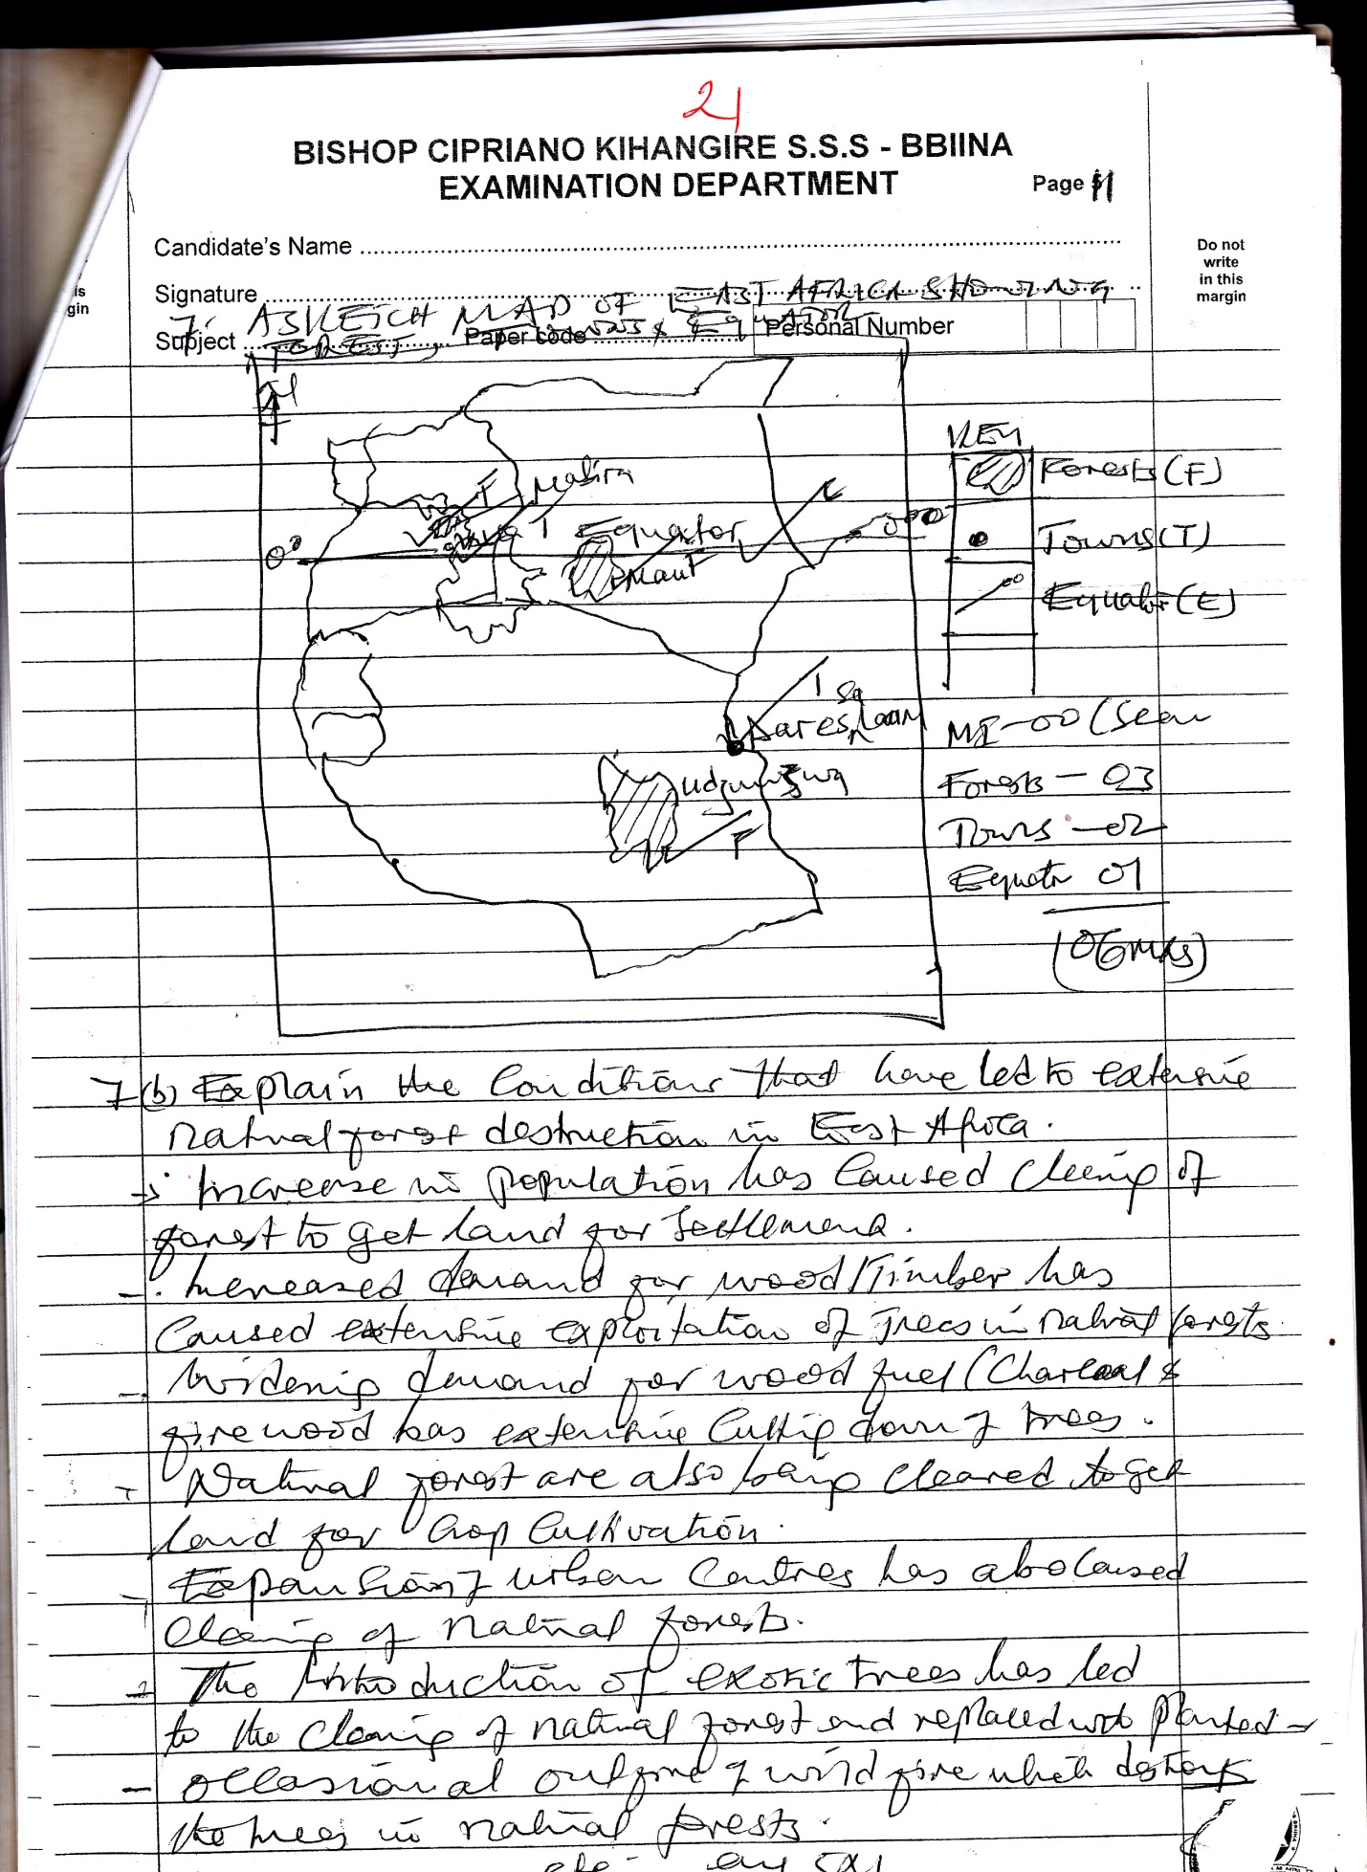

*b) Explain the conditions that have led to extensive natural forest destruction in East Africa. (05 marks)*

* *Increase in population has caused clearing of forest destruction in East Africa*
* *Increased demand for wood or timber has caused extensive exploitation of trees in natural forests*
* *Widening demand for wood fuel (charcoal and fire wood has extensive cutting down of trees*
* *Natural forests area also being cleared to get land for crop cultivation*
* *Expansion f urban centres has also caused clearing of natural forests*
* *The introduction of exotic trees has led to the clearing of natural forests and replaced with planted*
* *Occasional outfire of wild fire which destroys the trees in natural forests*

*Etc any 5 x 1*

*c) Outline the effects of forest destruction on the physical environment in East Africa. (05 marks)*

* *It has led to increase in surface temperatures through the creation of bare surfaces*
* *It has caused a reduction in annual rainfall totals through reduced water vapour*
* *It has created bare surface or secondary vegetation leading to soil erosion*
* *It has also destroyed the beautiful scenary created by the free canopy*
* *It has caused a reduction in water vapour due to reduced evapo transpiration*
* *Has caused a reduction in soil fertility through reduced supply of organic matter from forests*
* *Clearing of forests has led to destruction of habitats hence affecting run off leading to silting of water courses; causing floods.*

*Etc any 5 x 1*

*d) Suggest ways through which areas under forest cover can be expanded in East Africa. (04 marks)*

* *Legislation or formation of laws that regulate forest exploitation*
* *Afforestation can be encouraged to widen areas of forest cover*
* *Gazettign of forsted areas can be due to limited encroachers*
* *Mass education of the people on the value of forests*
* *Alternative sources of energy can be provided to reduce dependence on wood fuel*

*Any 4 x 1*

***END***